# Project: Analyzing a Market Test

Complete each section. When you are ready, save your file as a PDF document and submit it [here](https://classroom.udacity.com/nanodegrees/nd008/parts/11a7bf4c-2b69-47f3-9aec-108ce847f855/project).

## Step 1: Plan Your Analysis

*To perform the correct analysis, you will need to prepare a data set. (500 word limit)*

*Answer the following questions to help you plan out your analysis:*

1. What is the performance metric you’ll use to evaluate the results of your test?

The performance metrics that was used to evaluate the results is the distinct number of invoices per week per test unit which represent weekly foot traffic to each test unit.

1. What is the test period?

The test period for the experiment was 12 weeks, the experiment ran from April 29 2016 to July 21 2016.

1. At what level (day, week, month, etc.) should the data be aggregated?

The data was aggregated to the week level because a week represents a complete cycle for the experiment.

## Step 2: Clean Up Your Data

*In this step, you should prepare the data for steps 3 and 4. You should aggregate the transaction data to the appropriate level and filter on the appropriate data ranges. You can assume that there is no missing, incomplete, duplicate, or dirty data. You’re ready to move on to the next step when you have weekly transaction data for all stores.*

## Step 3: Match Treatment and Control Units

*In this step, you should create the trend and seasonality variables, and use them along with you other control variable(s) to match two control units to each treatment unit. Note: Calculate the number of transactions per store per week to calculate trend and seasonality.*

*Apart from trend and seasonality...*

1. What control variables should be considered? Note: Only consider variables in the RoundRoastersStore file.

Control variables that was considered in the analysis are:

1. StoreID
2. AvgMonthlySales
3. Region
4. What is the correlation between your each potential control variable and your performance metric?

The correlation between the AvgMonthlySales and Weekly_gross_margin is 0.71 which shows a high relationship between the control variable and the performance metric.

On the other hand, the correlation between the Sq_Ft and Weekly_gross_margin is 0.02 which shows no relationship between the control variable and the performance metric.

1. What control variables will you use to match treatment and control stores?

The control variables used to match the treatment stores to the control stores are:

1. Trend
2. Seasonality
3. Weekly gross margin per store
4. Please fill out the table below with your treatment and control stores pairs:

|  |  |  |
| --- | --- | --- |
| Treatment Store | Control Store 1 | Control Store 2 |
| 1664 | 12586 | 12019 |
| 1675 | 12786 | 3235 |
| 1696 | 3102 | 12286 |
| 1700 | 9968 | 2952 |
| 1712 | 10018 | 10468 |
| 2288 | 1807 | 1580 |
| 2293 | 8362 | 7770 |
| 2301 | 1863 | 7534 |
| 2322 | 7284 | 7584 |
| 2341 | 7162 | 1964 |

## Step 4: Analysis and Writeup

*Conduct your A/B analysis and create a short report outlining your results and recommendations. (250 words limit)*

*Answer these questions. Be sure to include visualizations from your analysis:*

1. What is your recommendation - Should the company roll out the updated menu to all stores?

From the A/B analysis carried out on the experiment, the result shows that the introduction of the new menu on the treatment units during the test period, there was an overall increase of in revenue of about 39% (Figure 3), this indicated that customers spent on average $663.1 more on the test units during the 12 weeks test period and with this significant increase in revenue, I recommend that the company should roll out the updated menu to all stores. I am confident that the increase in revenue will be reflected across all stores because the statistical significance of the analysis is 100%.

1. What is the lift from the new menu for West and Central regions (include statistical significance)?

The lift from the new menu in the West region is 45.3% with statistical significance of 99.6% (Figure 1).

The lift from the new menu in the Central region is 32.6% with statistical significance of 99% (Figure 2)

1. What is the lift from the new menu overall?

The lift from the new menu overall is 39% with statistical significance of 100% (Figure 3).

Figure 1: Lift and statistical significance from the West region.

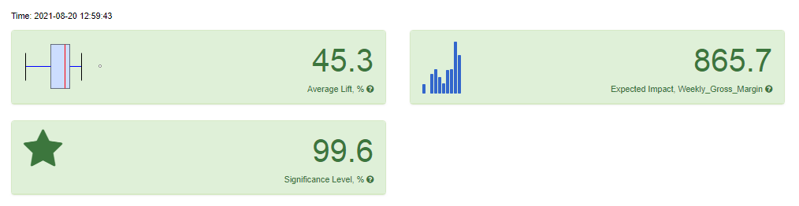

Figure 1: Lift and statistical significance from the Central region.

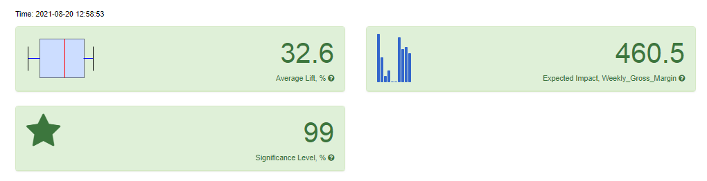

Figure 1: Lift and statistical significance from overall.

­